1/7/2024

Initial Project Planning

PRODUCTION PROJECT



SANDESH PAUDEL

THE BRITISH COLLEGE

UNIVERSITY ID: 77297958

**“SENIOR-SHIELD”: Next-Gen HealthCare App for Elderly**

# Project Aim:

The aim of "Senior-Shield" is to develop a next-generation healthcare app that uses IoT technology to provide complete monitoring, instant help, and improved well-being for the elderly, resulting in a safer and healthier aging experience.

# Objectives:

The objective of my project includes:

* Adaptive User interface catering to the specific needs of elderly users.
* Develop a system to monitor elderly health using IoT technology.
* Make sure falls get noticed quickly with smart technology.
* Help remember and take medicines on time.
* Alert caretakers fast if something seems off, using clever analytics.
* Chat to a doctor through the app for easy consultations
* Incorporate GPS and accurate location tracking and safety alerts.

# Project Specification

Senior-Shield uses IoT gadgets to keep track of health and remind about medicines. It operates as a Flutter-based smart app that can interact with these gadgets keeping everything safe and easy for older folks.

The following is a description of the product specification using the MoSCoW technique, which is divided into functional and non-functional requirements:

|  |  |
| --- | --- |
| Functional Requirements | MoSCoW |
| Continuous monitor of vital signs like heartrate, blood pressure and temperature using IoT devices | **M** |
| Fall Detection and Emergency Response | **M** |
| User Authentication and Authorization | **M** |
| Real Time Alerts and Notifications | **M** |
| Medication Management | **M** |
| Responsive UI | **S** |
| Location Tracking and GPS Integration | **S** |
| Chat Service Integration with Doctor | **S** |
| Integration of Brain Games | **C** |
| Chat with Friends | **C** |
| Offline Capability | **C** |

|  |  |
| --- | --- |
| Non-Functional Requirements | MoSCoW |
| Security Measures with Data Encryption | **M** |
| Easy To Use for Seniors and Understandable | **M** |
| Smooth Working with Traffic Handling | **M** |
| Compatibility With Multiple Devices | **S** |
| Continuous Improvement with Feedback and new technology | **S** |
| Awareness Messages | **S** |
| Aesthetic Appealing | **C** |

# Research

The well being of the elderly people is significantly impacted by the risks of the falls, fluctuation of blood pressure, heart rate and body temperature. Timely detection of these risk factors is necessity for enhancing their quality of life (Durán-Vega, et al., 2019). Younger generations working may leave elderly at home posing safety and care of them. Affordability of nurse could also be an issue. IoT has been boon for them (Madhu, et al., 2023). A development of physiological sensory system and advancement of stable wireless network allows efficient monitoring of the old ones (Guizani & Guizani, 2020). Acc to the (Roy, et al., June 2022) the wearable devices featuring tri-axial accelerometer, pulse sensor, wireless connectivity, GPS for location tracking and emergency alert via mobile application can provide high accuracy of 97.6% for minimizing the impacts of falls and other risk factors through timely caregiver intervention.

# Evaluation

The "Senior-Shield" project's final evaluation aligns with fulfilling project specifications, incorporating essential features like health monitoring, fall detection, medication management, and real-time alerts. The user-friendly interface, enriched by IoT device integration, forms a comprehensive health profile. Flutter proves effective for development, and robust security measures, including data encryption and privacy compliance, enhance system security. Evaluation methods encompass qualitative aspects like user experience and quantitative metrics such as performance and accuracy. The product's outcome determines system efficiency and accuracy, with real-time alert response as a key factor.

# Project Planning and Methodology

## Methodology

Agile software development provides greater flexibility in comparison to a plan-driven approach (Ghimire & Charters, 2022). Embracing the Agile Methodology, this project “Senior-Sheild” undergoes iterative development, dividing the whole project into multiple phases or sprints. Regular feedback will be taken after each sprint review with the supervisor. If not daily, one or two meeting a week will be conducted to discuss the progress and further improvisation in the project. To visualize the project progress, a Gantt chart and the project timeline have been created. During the process, project specification that consists of health monitoring, fall detection, medication management and User-Friendly Interface will be highly taken into consideration. This agile driven approach gives surety for an efficient, collaborative, and adaptive framework, that helps ultimately reaching the goal that is a responsive healthcare solution for elderly.

## Project Timeline

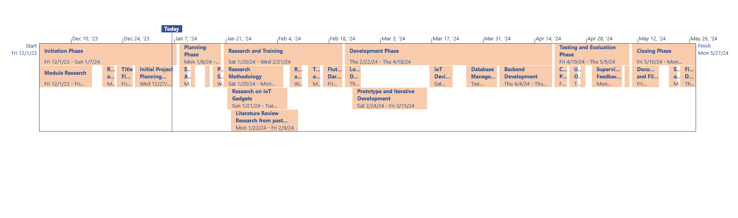

Figure Timeline showing the project progress.

## Gantt Chart

Figure Gantt Chart for the Project Task Division into Multiple Phases

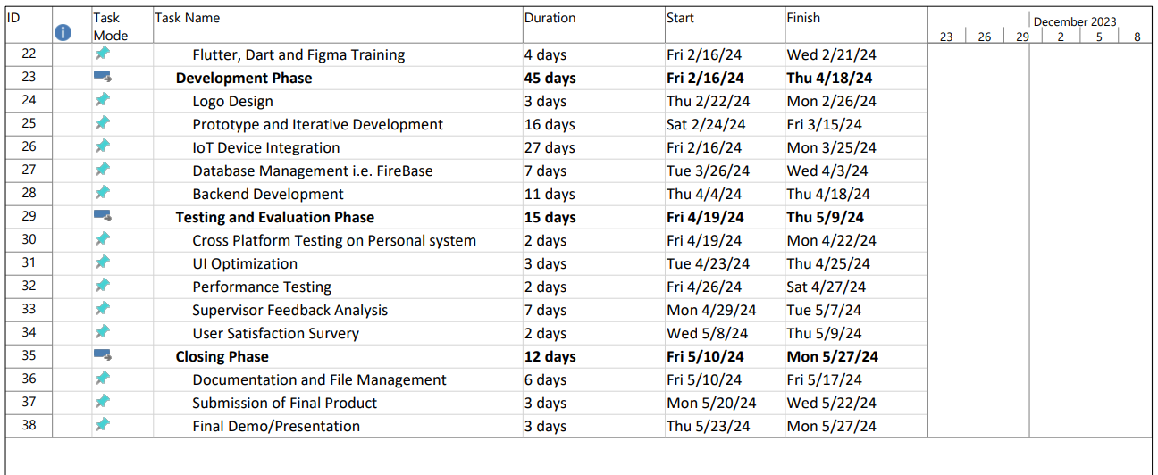

# Resources

The list of the resources that are to be used in this project are as follows. The software downloaded here are open source and can be accessed easily.

## Human Resources

I am working on this project with the following people.

**Name: Sandesh Paudel**

**Module Leader: Anita Gurung**

**Supervisor:**

## Software

* Android Studio (IDE For App Development)
* Flutter and Dart (Flutter is a Cross Platform Framework for Dart for Mobile App Development)
* Firebase Cloud (Cloud Database for Storing and Retrieving Real Time Data)
* Visual Studio Code
* GitHub (Version Control System)
* MS Word
* MS Project
* MS PowerPoint
* Arduino IDE (Integrated development environment for programming Arduino microcontrollers)
* Brave (Web Browser)
* ChatGPT
* Figma
* Google Meet

## Hardware

* Lenovo Legion Laptop
* AMD Ryzen 5
* Node MCU
* Heart Rate Sensor
* ECG Sensor

# Bibliography

Durán-Vega, L. A. et al., 2019. An IoT System for Remote Health Monitoring in Elderly Adults Through a Wearable. *Geriatrics (Basel),* 4(2), p. 34.

Ghimire, D. & Charters, S., 2022. The Impact of Agile Development Practices on Project Outcomes. *Software Engineering and Applications,* 5 August, 1(3), pp. 265-275.

Guizani, K. & Guizani, S., 2020. IoT Healthcare Monitoring Systems Overview for Elderly Population. *2020 International Wireless Communications and Mobile Computing (IWCMC),* pp. 2005-2009.

Madhu, S., Jyothi, K., Pravallika, S. & Sridurga, N., 2023. *IoT-Enabled Applications for Elderly Support and Care: A Systematic Review.* Singapore, Springer Nature Singapore.

Roy, H. S., Khondakar, M. F. K. & Sarowar, M., June 2022. Internet of things based fall detection and heart rate monitoring system for senior citizens. *International Journal of Electrical and Computer Engineering (IJECE).*